Tools for Managing Civilian Employees

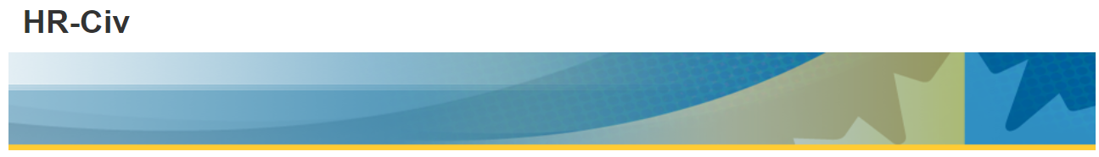

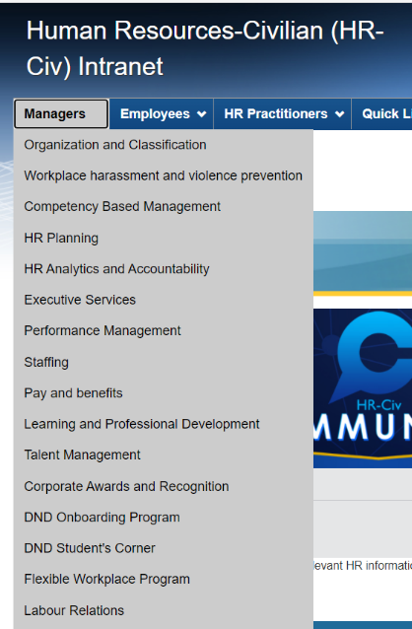
The ADM HR-Civ Website provides information geared specifically to managers on a variety of HR subjects:
http://hrciv-rhciv.mil.ca/en/index.page

ADM(HR-Civ) offers multiple ways to access our services:

Centres of Expertise (COEs)
If you are trying to contact someone within a specific COE such as staffing, classification, compensation, etc., browse through our list of COE contacts which organized by teams and/or by L1.


HR GO RH
HR GO RH, HR-Civ’s mobile app, puts civilian HR information and tools at your fingertips.
Download today through Apple’s App Store or Google Play.



HR Connect RH
HR Connect RH offers quick and easy access to civilian HR information, services and programs.
Start here with a simple click, or call 1-833-747-6363.

Staffing Delegation Sub-delegation Training
For the Department of National Defence, the mandatory sub-delegation training consists of an online course, titled Staffing Sub-delegation for Managers, which is available through the Defence Learning Network (DLN).
This online course gives reference to key elements of the Public Service Employment Act (PSEA), as well as directives and policies governing staffing. It explains the roles and responsibilities of the sub-delegated manager related to their accountability for staffing activities.
The goal of this course is to enable sub-delegated managers to:
- Make informed decisions and exercise their sub-delegated authority in accordance with various legislative and policy requirements;
- Ensure a balanced consideration of the core and guiding staffing values, which contributes to a strong staffing system and supports having the right person in the right position at the right time.
Upon completion of the course and successfully passing the exam, managers will be required to submit a signed Appointment Sub-Delegation and Accountability Agreement before being sub-delegated appointment and appointment-related authorities.

